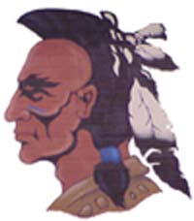NORTHWEST HIGH SCHOOL
914 Mohawk Drive
McDermott, Ohio 45652-9000

Telephone: (740) 259-2366 Fax: (740) 259-8544
Web Site Address: www.Northwest.k12.oh.us

Local Superintendent | Board of Education | High School Principal
A. Todd Jenkins | Keith Crabtree, President | R. Jason Burton
Todd.Jenkins@nwmohawks.org | Jill Carver, Vice President | Jason.Burton@nwmohawks.org
 | Jason Taylor, Member
Treasurer | Jared Lute, Member | Assistant High School Principal
Julie L. Smith | Adam Jones, Member | Terri Freeman
Julie.Smith@nwmohawks.org |  | Terri.Freeman@nwmohawks.org

Dear Student,
We are pleased to inform you of your selection in the Northwest Honors Club for the school year 2017-2018. Students are selected based upon meeting the honors club criteria established by school policy and is posted on page 22 of the student handbook.
The honors club represents the best and brightest students that reflect our academic community. We invite you and your parent(s)/guardian(s) to join us in this academic celebration of your success.
Northwest Honors Club recipients will be recognized on Friday, April 20th, 2018 at 1 p.m. during our honors assembly in the gymnasium. We would ask that you dress appropriately for the awards ceremony.
Congratulations on your selection, and I would encourage you to continue to work hard in the classroom.

Mr. Tim Amburgey

Honors Club Advisor

