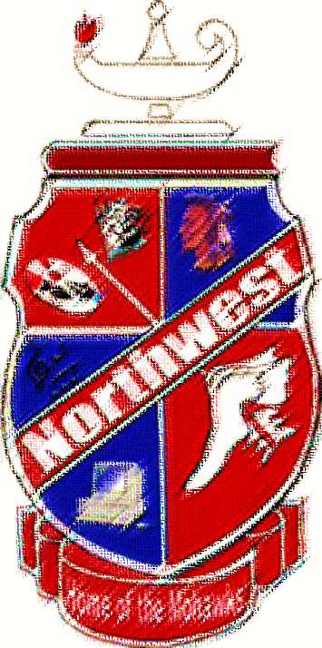
Honors Club
Freshman Class of 2021

Haidyn Wamsley
Katricia Eldridge
Katie Argueta
Cierra Gilley
Abigail Colley
Ellie Curtis
Kayla Bender
Terah Webb
Rebecca Blaine
Brandon Bostwick
Brianna Kelly-Chandler
Breana Howell
Gabriel Morrell
Caleb Crabtree
Landen Smith
Kaden Zumbro
Valerie Eury
Haley Montavon
Kayeleigh Reinhardt

Tiffany Horn
Josie Myers
Aaron Jenkins
Kyle Butler
Ethan Smith
Brie Dalton
Braden Groves
Kenzie Boehm
Luke Howard
Chloe McIntire
Makayla Isaac
Joshua Shope
Antonia Smith
Lydia Emmons

