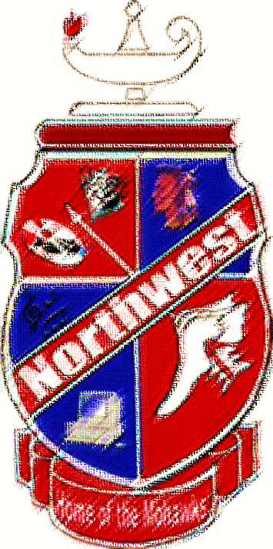
Honors Club
Sophomore Class of 2020

Jacob Lynn
Kali Journey
Raenna Roepke
Kelsey Isley
Kady Wamsley
Ashley Morgan
Kylie Sparks
Dustin Eichenlaub
Rebecca Stevens
Madison Thomas
Sarah Barlow
Jared Breech
Timothy Emmons

Gracie Ferrar
Gregory Richardson
Logan Smith
Addisyn Newman
Jenna Meddock
Madison Montavon
Kariann Lawson
Donna Osburn
Mary Faulkner
Hollie Crabtree
Jordan Glenn
Kaley Hamilton
Morgan Ferguson

