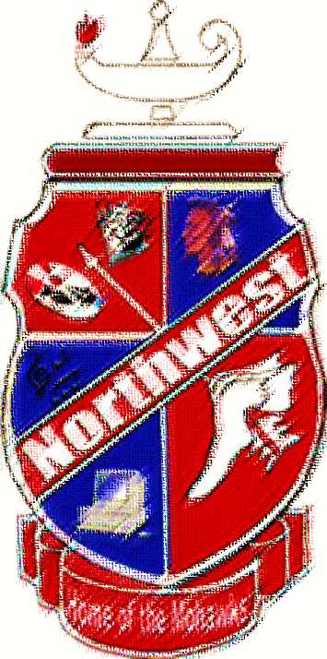
Honors Club
Juniors Class of 2019

Hannah Beck
Evan Throckmorton
Sydnie Jenkins
Shannon Browning
Laiken Rice
Sydney Throckmorton
Patrick Redoutey
Harold Rundquist
Skylar Patty
Bethanie Green
Aidaen Gee
Grace Seison
Christian Johnson
Jordan Piatt
Hanna Tackett
Alyson Chambliss

Megan Mitchell
Haley Holbrook
Whitney Breech
Colleen McClay
Ryan Penix
Thomas Hobbs
Abbygail Messer
Hannah Crabtree
Brandon Hobbs
Trinity Hopper
Madison Damron
Joseph Varney
Blake Hatfield
Logan Little
Sarah Moore

