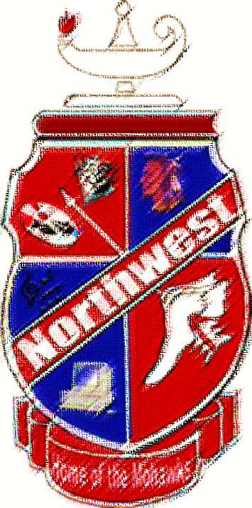
Honors Club
Seniors Class of 2018

Kelsey Shope
Matthew Hamilton
Abbigayle Munyon
Grady Montavon
Will Gillette
Payton Dever-Bracken
Alissa Lacy
Brookelyn Ferguson
Kaitlyn Lawson
Alisha Maddy
Joshua Stamper
Kyle Leslie
Morgan Crank
Abigail Baer
Alexis Hubbard
Katelyn Rachford
Josie Tackett
Jamie Worthington
Seth Hall

Mason Rose
Courtney Pollard
Sarah Ellis
Haleigh Ross
Shawnte Meadows
Darren Webb
Mikayla McGuire
Mollie Ferrar
Grace Burchett
Jacob Goodson
Samantha Ellis
Johnathon Snyder
Kaleb Smith
Jamie Ellis
Houston Richard
Austin Jewett
Jareth Phipps
Creed Burton
Shelby Simons

